5.68: (a) Choosing upslope as the positive direction:
and
Since we know the length of the slope, we can use 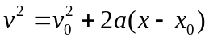 with 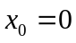 and 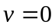 at the top.
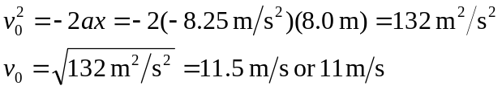
(b) For the trip back down the slope, gravity and the friction force operate in opposite directions:
Now
